The ALiEMU website (the site we link to for III assignments) has recently changed its Educator Dashboard to a "Khan Academy" format and now requires you to assign "coaches" in order for us to be able to view documentation of your completed modules.

Please go to ALiEMU (https://www.aliemu.com) and assign both myself and Elise as coaches. If you have already registered for prior III, go to your home page on the ALiEMu website and click on "Groups"
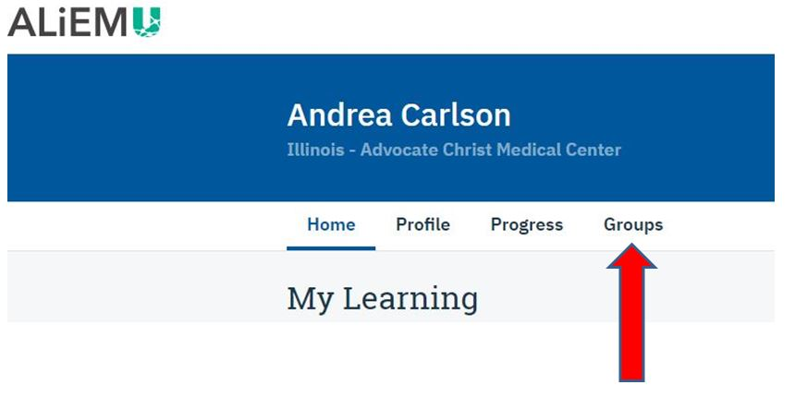
Then in the section "My coaches" enter my email address acarlsonmd@comcast.net and click the blue "add coach" button. If you have affiliated with our program my name should then show up just below as a coach. Then please do the same using Elise's email eliselovell@gmail.com. Once you have done this you will also show up as learners on our dashboard and we will be able to track your completed III modules.
If you have not yet been on the ALiEMu website you will of course first need to register; when you do this make sure you affiliate with our program (you can just search it by name, no code is needed).

Let me know if you encounter any problems.
Thanks!
Andrea

